GenAI Introduction:
ChatGPT means you are chatting with GPT.
What is GPT?
->GPT is basically LLM

- What is LLM?
- LLM is Large language Model which is Artificial Intelligence system, trained to understand and generate human language.
- It uses Machine Learning , with deep learning using neural network to process and generate in a way that understand and mimic human like understanding and conversation.
- We have trained data with whole internet stuffs.
- Gemini is LLM of google
- They scrape the data,process the data,training data in context of AI
- Using LLM you can talk to machine in natural language.
*Understand natural language and generate natural language

Deep Dive into GPT architecture:

- How LLM works?
- User Input-><Input Token>->Hi-> LLM->Hey there->Output token
- 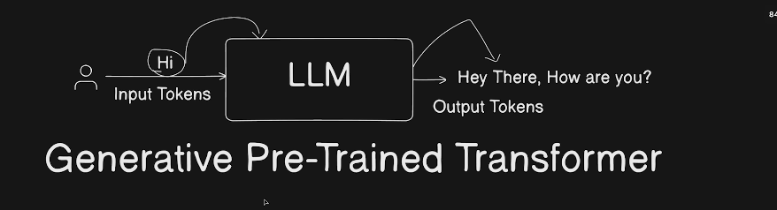
Generative Pre-trained Transformer
Google is search engine, it is not generating content for me.
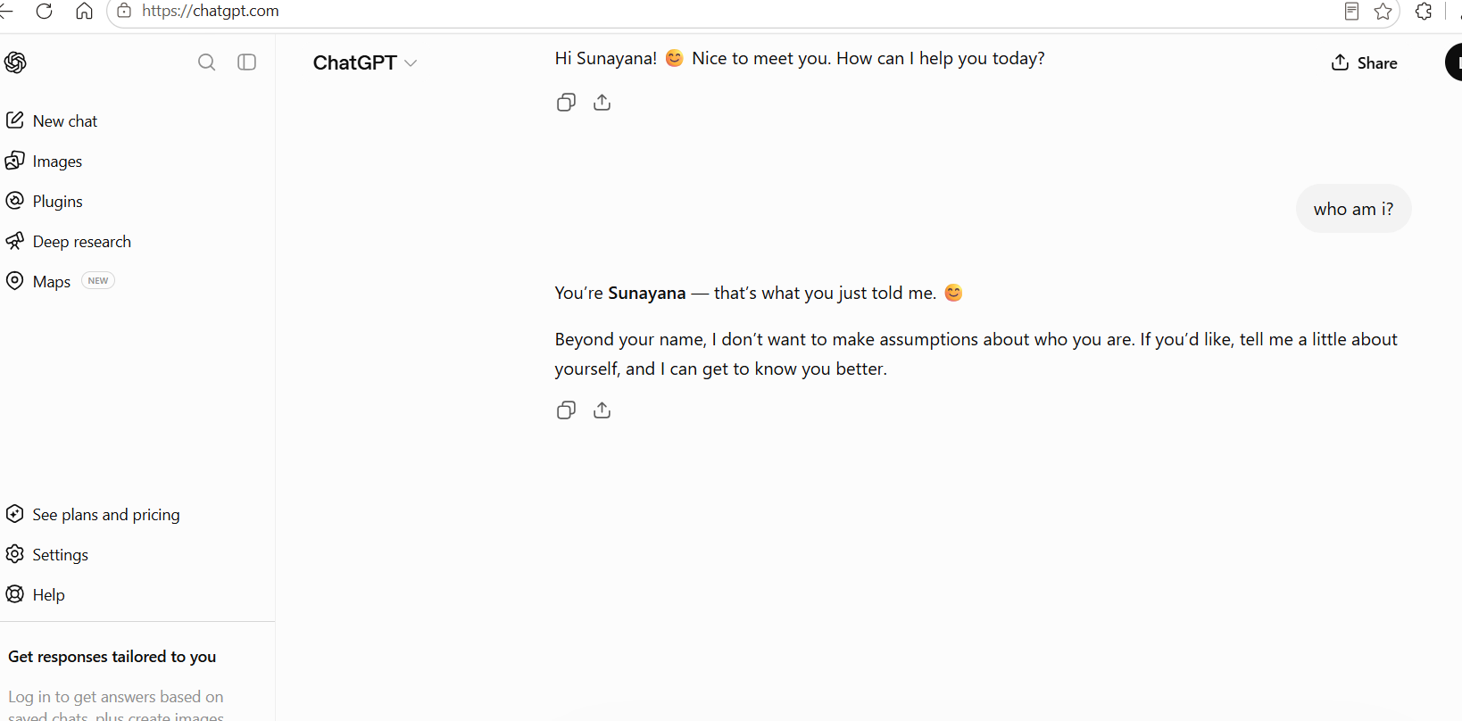
On basis of some information it generates information.

Generative is nature.
They are generative on the basis of pre-trained data.
Transformer is reality

3.How LLM works under the hood?

->Transformer is core meat part of GPT.
1706.03762
Research paper by google : Attention Is All You Need

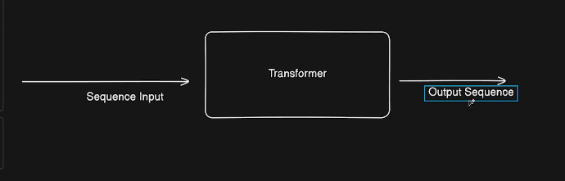
Used by Google translate
Google transformer turned English seq->hindi seq, English seq->French seq

Using machine learning pre-trained data they did above.

GPT on other hand takes input token and predicts the next token:
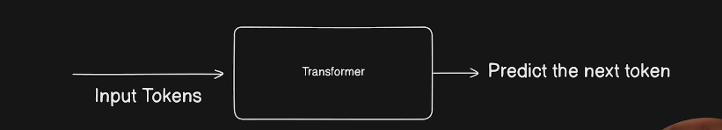

GPT transformer

Step 1:
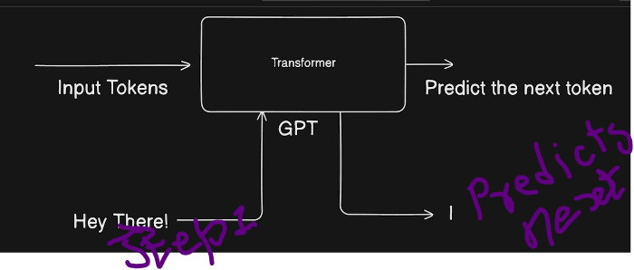

Step 2
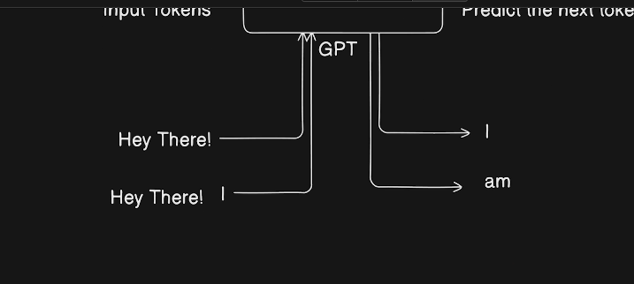

Step3:
Predicts next token
You give “Hey, there I am”-> transformer gives <space> good.
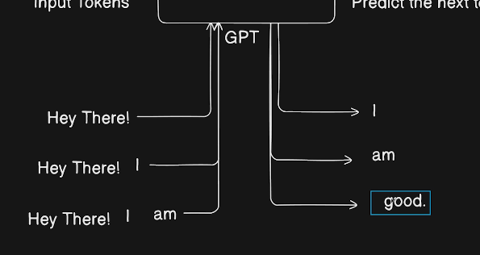

Step 4:
At the end transformer gives you <END>
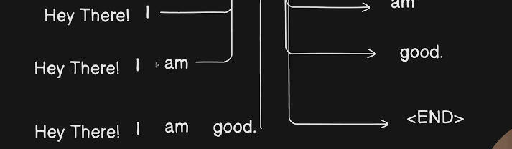

For any input token, it predicts only 1 next output token.

Repeating so many times so it is very CPU intensive process, so it requires GPU.

Tokenization and Tokens:
Tokens have definition which varies from model to model.
Lets say every alphabet is a token, A is token, B is token…
Computers are good in maths.
We can give no to this token.
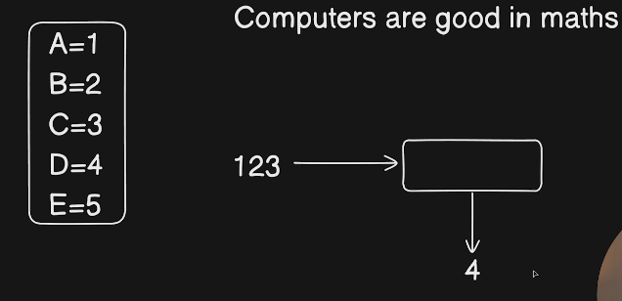

If you give token 123 to transformer it can very well predict next token to 4.
Token is basically what you input is mapped to a number.
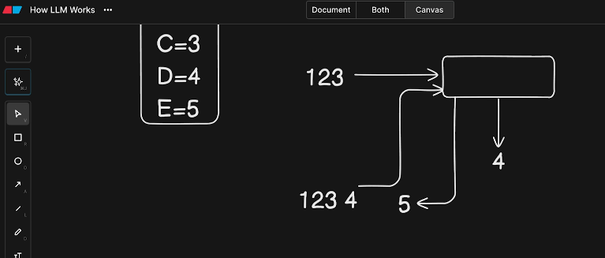
The characters that human use are mapped to some numbers.
Token system for gpt-4,Gemini,claude,gpt3.5 is different.
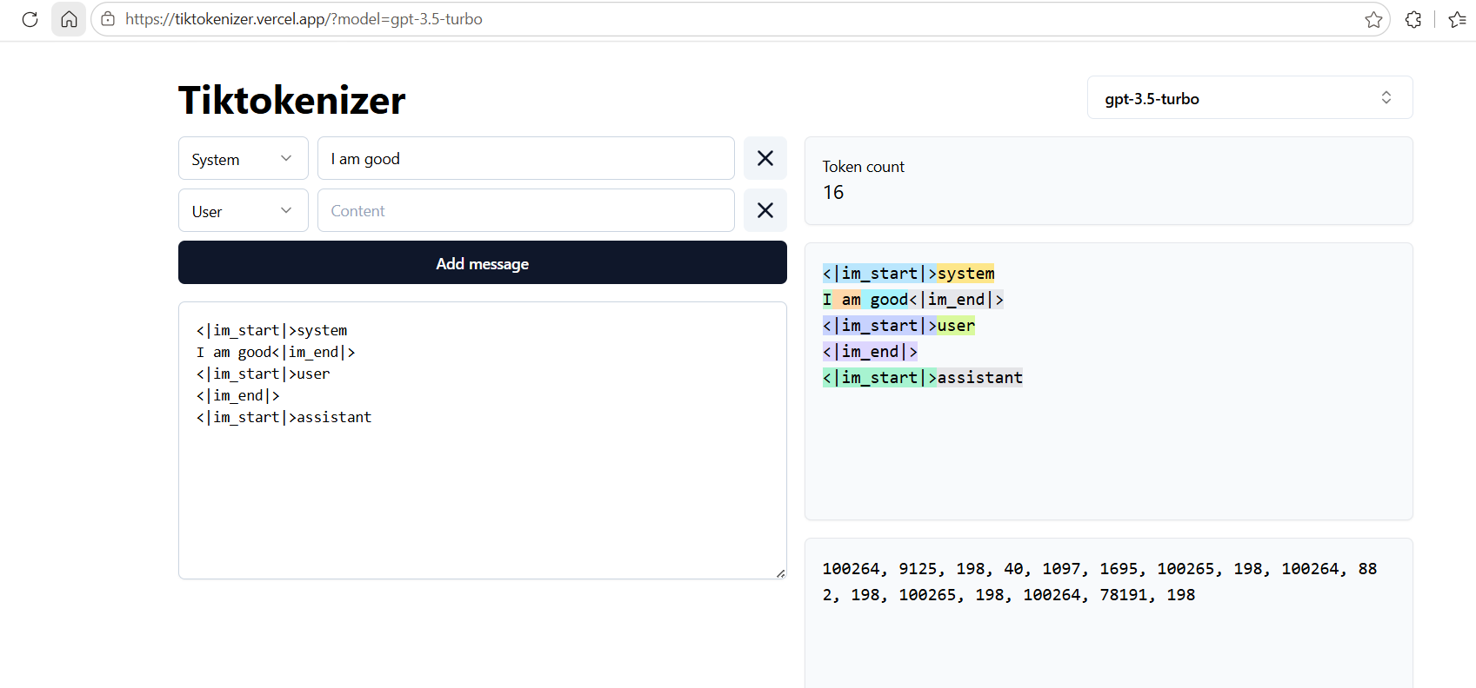
Tiktokenizer
Detokenizer is changing tokens(numbers to English)

